
Company
Logotype

Cone Beam Computed Tomography- Report



Porur Dental X-rays & CBCT

Patient Name : Miss. Hiranmayee | Date of Report : 13.04.2024
Age/ Gender : 15 years/ Female | Region of Interest : CBCT Maxilla
Referring doctor: Dr. Revathy | Indication : Impacted tooth
Clinical Notes: Nil
PATIENT INFORMATION

CBCT Maxilla provided
CBCT – IMAGE DETAILS

RADIOGRAPHIC INTERPRETATION

- Deciduous teeth: 53, 63;
- The tooth 13 appears to be obliquely placed within the alveolar bone, distally tipped and lies above the periapical aspect of the deciduous tooth: 53 and its root in proximity to the medial wall of right maxillary sinus.
- The tooth 23 appears to be obliquely placed within the alveolar bone, distally tipped and lies above the periapical aspect of the deciduous tooth: 63 and its root in proximity to the medial wall of right maxillary sinus.
- Both the impacted teeth 13, 23 lie palatal to the deciduous teeth 53 and 63 respectively.
- The crown of the impacted 13 is in contact with the root portion of 12.
- Distance between the crown of 13 and the alveolar ridge: 2.53 mm
- Distance between the crown of 23 and the alveolar ridge : 2.12 mm

RADIOGRAPHIC IMPRESSION


- Impacted teeth: 13, 23
- Retained deciduous teeth: 53, 63

IMAGES FOR REFERENCE

RECONSTRUCTED PANORAMA VIEW
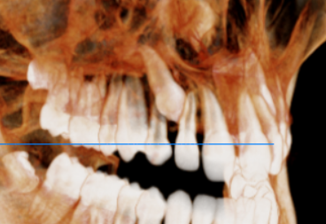
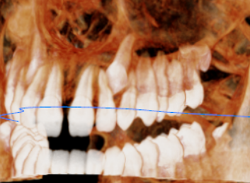
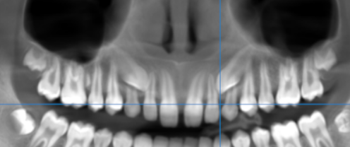
3-DIMENSIONAL VIEW
CROSS- SECTIONAL IMAGES
13 REGION | 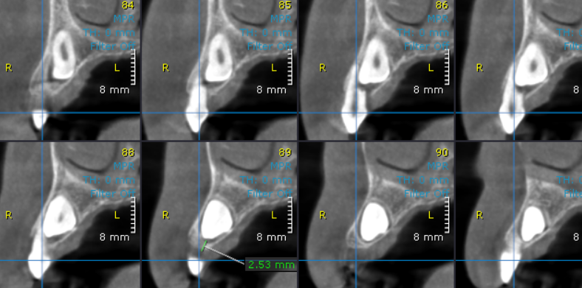
23 region | 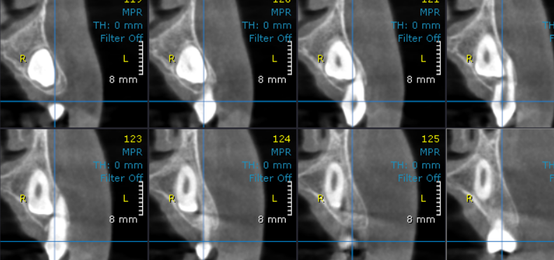

**** End of report ****

